**DSA Project**

**By Cyber Chasers Team**

**Features Implemented**

* Login System
* Blue and White User Interface
* Logged in Users of Disqus can Comment
* There are three different roles made in Disqus--DSA Committee, Admin, and Student
  + Student can edit their own comment
  + DSA Committee and Admin can edit their own comments and delete other people’s comments
* Every blog is associated with a tag
  + Any user can search for blog posts with a specific tag by clicking on the tag
* Website is Deployed Online

**Features That Remain to be Done**

* Create Blog Posts through the Website
* Admin client routes
* Delete Tags page and add the tag list to the Blog listing page
* FAQ Page that is Dynamic
  + User can toggle between admin, DSA Committee, and Student questions easily

**Known Issues**

There are two login systems--Netlify and Disqus. The user would also need to signup for Disqus to comment, and the admin needs to manage roles for Disqus as well, which can make managing this website more tedious. When you click on Events, Domain Elective, or News, all posts appear instead of posts of the respective category.

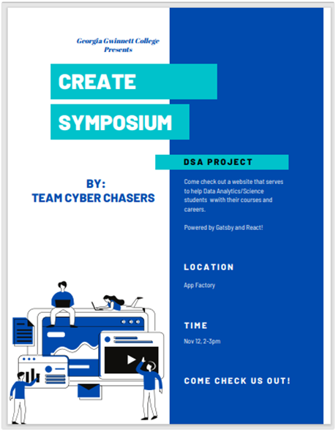

[Screencast of Project](https://www.youtube.com/watch?v=DLxnb4lmBLw)

**Cyber Chasers Team Introduction**

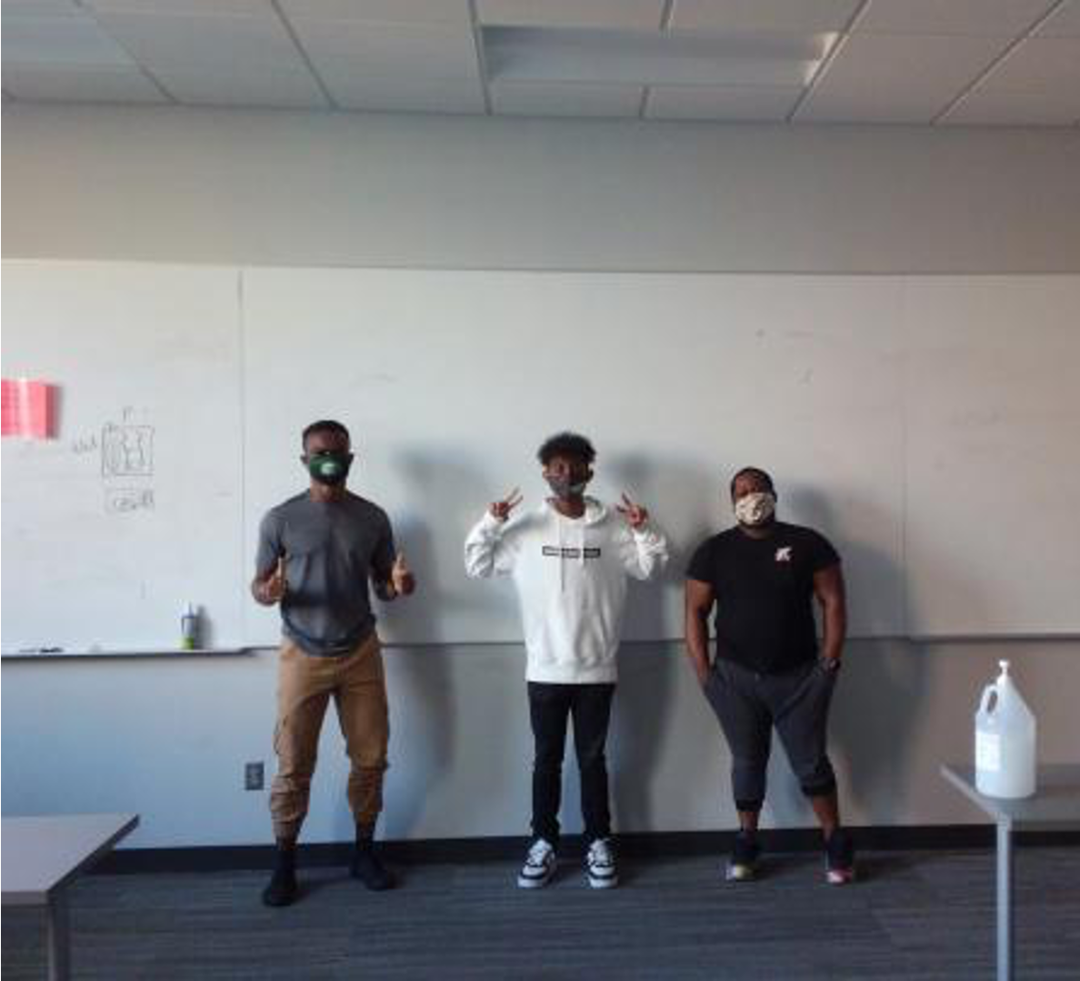

From Left to Right

Agapitus Iboro, Alex Abraham, Sebastien Pierre-Louis

**Alex Abraham** -

1. Lead Programmer: 70% 2. Team Manager 30%

Software Dev Concentration, Senior

**Sebastien Pierre-Louis** -

1. Data modeler: 90% 2. Client Liaison: 10%

Software Dev Concentration, Senior

**Agapitus Iboro** -

1. Lead Testing : 70% 2. Helper Programmer: 30%

Software Dev Concentration, Senior

**May Kamreen** -

1. UX/UI Design: 70% 2. Documentation Lead: 30%

Data Analytics/Science Concentration, Senior

**Dr. Gunay (Client) Introduction**

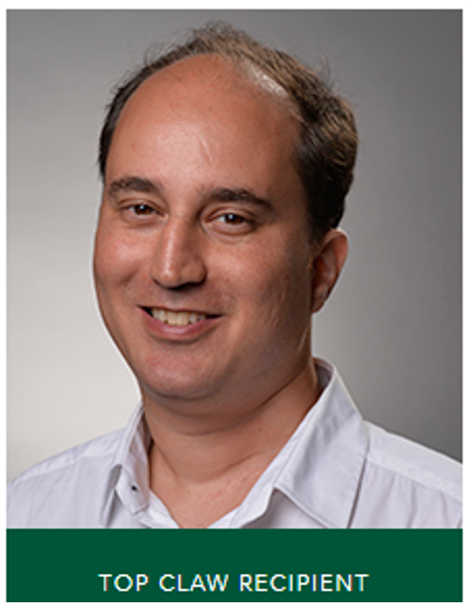

Dr. Cengiz Gunay is an Assistant professor of information technology at Georgia Gwinnett College. He has his bachelors in electrical engineering, Masters in computer science, and a doctorate in computer science both at the university of Louisiana at Lafayette.

Academic interests include software engineering, data science and Artificial intelligence/machine learning. He is Advisor of Grizzly Hacks Student Organization and is part of the Data Science/Analytics Committee.

**Testing**

Simple snapshot test to check for regressions by comparing future snapshots against this

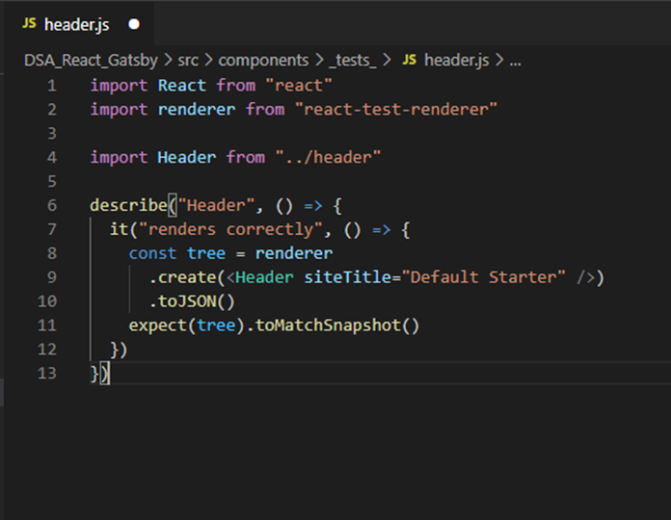

Test Gatsby components

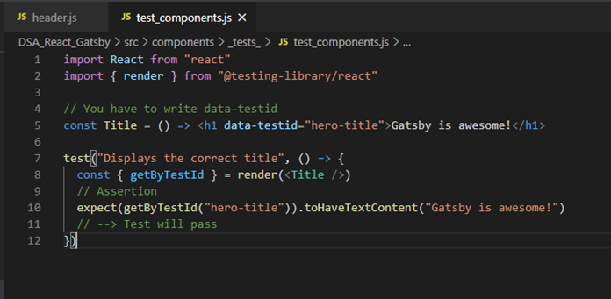

**Usability Testing/Focus Group Survey Results**

We had people during CREATE presentations try out our website and offer feedback through a survey. Results are below.

|  |  |  |  |  |
| --- | --- | --- | --- | --- |
| How good looking is it? | How useful is it? | Is it a complete product? | Do you have an idea for another app? | Any other comments? |
| 5 | 5 | 5 | No | Great work! |
|  | 5 | 5 | No |  |
| 5 | 5 | 4 | No | Nice App. |
| 5 | 5 | 5 | No | Great job |
| 5 | 5 | 4 | No | Nice functionalities. Good job!! |
| 5 | 5 | 5 | No |  |
|  | 5 | 5 | No |  |
|  | 5 | 5 | No |  |
|  | 5 | 5 | No | I really liked it, they did a great job. Makes me want to become a DSA major. |
| 5 | 4 | 4 | No | Looked good |
| 5 | 5 | 5 | No |  |
| 5 | 5 | 4 | No | great UI and great job at implementing a login and commenting system |
| 5 | 4 | 5 | No | Great Job |
| 5 | 5 | 5 | No | n/a |
| 5 | 4 | 4 | No | Really like the UI |
| 5 | 5 | 5 | No | I really enjoyed the professionalism and how smooth the presentation went. They did a good job. |

**Installation, Developer, and User Documentation**

**Installation**

**Not necessary, you can just go to our live site here:** [**https://trusting-hopper-84508b.netlify.app/**](https://trusting-hopper-84508b.netlify.app/)

[**Developer Documentation**](https://github.com/GGC-SD/dsa/blob/master/docs/developer.md)

**User Documentation:**

[**Admin FAQ**](https://github.com/GGC-SD/dsa/blob/master/docs/faqadmin.md)

[**DSA Committee FAQ**](https://github.com/GGC-SD/dsa/blob/master/docs/faqdsacommittee.md)

[**Student FAQ**](https://github.com/GGC-SD/dsa/blob/master/docs/faqstudent.md)

**Software Usage Terms and Intellectual Agreement**

[Software License](https://github.com/GGC-SD/dsa/blob/master/docs/LICENSE.md)

[Intellectual Agreement](https://github.com/GGC-SD/dsa/blob/master/docs/Intellectual_Agreement-DSA.pdf)